

**UCS1711 - MOBILE APPLICATION DEVELOPMENT LAB**

**Assignment 11**

Name: Jayannthan P T

Dept: CSE ‘A’

Roll No.: 205001049

Menu Driven Application

**Ex. No:11**

**Title of the Program:** Develop a Menu driven App that displays the option menu that contains names of different countries and when each of the country is clicked, the description about the country should be displayed.

**Objective:**

The objective of the Menu Country App is to create a menu-driven Android application that displays a list of countries. When a user clicks on a specific country, the app should show a description of that country.

**Algorithm:**

1. Create a MainActivity with TextViews for displaying the selected country and its description.
2. Override onCreateOptionsMenu to inflate the menu with country names.
3. Override onOptionsItemSelected to handle user clicks on the menu items and display the corresponding country description.
4. Create a menu XML file (Countries.xml) with items representing different countries.
5. Include string resources (strings.xml) for country descriptions.
6. Design the layout using XML (activity_main.xml) with ConstraintLayout and TextViews for country details.

**Features used:**

1. Menu creation and handling using onCreateOptionsMenu and onOptionsItemSelected.
2. TextViews for displaying the selected country and its description.
3. Menu XML (Countries.xml) to define the list of countries.
4. String resources (strings.xml) for storing country descriptions.
5. ConstraintLayout in the layout XML (activity_main.xml) for a responsive UI.

**Source code:**

* MainActivity.java

package com.example.menucountry;

import androidx.appcompat.app.AppCompatActivity;

import android.os.Bundle;

import android.view.Menu;

import android.view.MenuInflater;

import android.view.MenuItem;

import android.widget.TextView;

public class MainActivity extends AppCompatActivity {

    TextView country, desc;

    @Override

    protected void onCreate(Bundle savedInstanceState) {

        super.onCreate(savedInstanceState);

        setContentView(R.layout.activity_main);

        country = findViewById(R.id.country);

        desc = findViewById(R.id.desc);

    }

    public boolean onCreateOptionsMenu(Menu menu) {

        MenuInflater inflater = getMenuInflater();

        inflater.inflate(R.menu.country, menu);

        return true;

    }

    @Override

    public boolean onOptionsItemSelected(MenuItem item) {

        int id = item.getItemId();

        switch (id) {

            case R.id.ind:

                country.setText("India");

                desc.setText(R.string.india);

                return true;

            case R.id.bah:

                country.setText("Bahrain");

                desc.setText(R.string.bahrain);

                return true;

            case R.id.pak:

                country.setText("Pak");

                desc.setText(R.string.pakistan);

                return true;

            case R.id.is:

                country.setText("Israel");

                desc.setText(R.string.israel);

                return true;

            case R.id.chn:

                country.setText("China");

                desc.setText(R.string.china);

                return true;

            case R.id.can:

                country.setText("Canada");

                desc.setText(R.string.canada);

                return true;

            case R.id.uk:

                country.setText("UK");

                desc.setText(R.string.uk);

                return true;

            default:

                return super.onOptionsItemSelected(item);

        }

    }

}

* activity_main.xml

<?xml version="1.0" encoding="utf-8"?>

<androidx.constraintlayout.widget.ConstraintLayout xmlns:android="http://schemas.android.com/apk/res/android"

    xmlns:app="http://schemas.android.com/apk/res-auto"

    xmlns:tools="http://schemas.android.com/tools" android:layout_width="match_parent" android:layout_height="match_parent" tools:context=".MainActivity">

    <TextView android:id="@+id/country" android:layout_width="wrap_content" android:layout_height="wrap_content" android:text="" android:textColor="@color/black" android:layout_margin="48dp" android:padding="24dp" android:textSize="24dp" android:textStyle="bold" app:layout_constraintEnd_toEndOf="parent" app:layout_constraintStart_toStartOf="parent" app:layout_constraintTop_toTopOf="parent" />

    <TextView android:padding="24dp" android:layout_margin="24dp" android:id="@+id/desc" android:layout_width="320dp" android:layout_height="wrap_content" app:layout_constraintTop_toBottomOf="@+id/country" app:layout_constraintEnd_toEndOf="parent" app:layout_constraintStart_toStartOf="parent" />

</androidx.constraintlayout.widget.ConstraintLayout>

* Countries.xml

<?xml version="1.0" encoding="utf-8"?>

<menu xmlns:android="http://schemas.android.com/apk/res/android">

    <item android:id="@+id/ind" android:title="India" />

    <item android:id="@+id/bah" android:title="Bahrain" />

    <item android:id="@+id/pak" android:title="Pakistan" />

    <item android:id="@+id/is" android:title="Israel" />

    <item android:id="@+id/can" android:title="Canada" />

    <item android:id="@+id/uk" android:title="UK" />

    <item android:id="@+id/chn" android:title="China" />

</menu>

* strings.xml

<resources>

    <string name="app_name">Menu Country App</string>

    <string name="india">India, officially the Republic of India (ISO: Bhārat Gaṇarājya), is a country in South Asia. It is the seventh-largest country by area; the most populous country as of June 2023; and from the time of its independence in 1947, the world\'s most populous democracy</string>

    <string name="pakistan">

        Pakistan (Urdu: پَاکِسْتَان [ˈpaːkɪstaːn]),[d] officially the Islamic Republic of Pakistan (ISO: اِسْلامی جَمْہُورِیَہ پَاکِسْتَان, islāmi jamhūriyāh pākistān), is a country in South Asia.

    </string>

    <string name="bahrain">

        Bahrain (/bɑːˈreɪn/bah-RAYN, /ˈreɪn/; Arabic: البحرين, romanized: al-Baḥrayn, locally [æl baħˈreːn]), officially the Kingdom of Bahrain,[a] is an island country in West Asia.

    </string>

    <string name="israel">

        Israel is a country in West Asia. It is bordered by Lebanon to the north, by Syria to the northeast, by Jordan to the east, by the Red Sea to the south, by Egypt to the southwest, by the Mediterranean Sea to the west, and by the Palestinian territories – the West Bank along the east and the Gaza Strip along the southwest. In war please try later

    </string>

    <string name="china">

        China , officially the People\'s Republic of China (PRC),[k] is a country in East Asia.

    </string>

    <string name="canada">

        Canada is a country in North America. Its ten provinces and three territories extend from the Atlantic Ocean to the Pacific Ocean and northward into the Arctic Ocean, making it the world\'s second-largest country by total area,

    </string>

    <string name="uk">

The United Kingdom of Great Britain and Northern Ireland, commonly known as the United Kingdom (UK) or Britain,[k][14] is an island country in Northwestern Europe, off the north-western coast of the continental mainland.

    </string>

</resources>

**Output:**

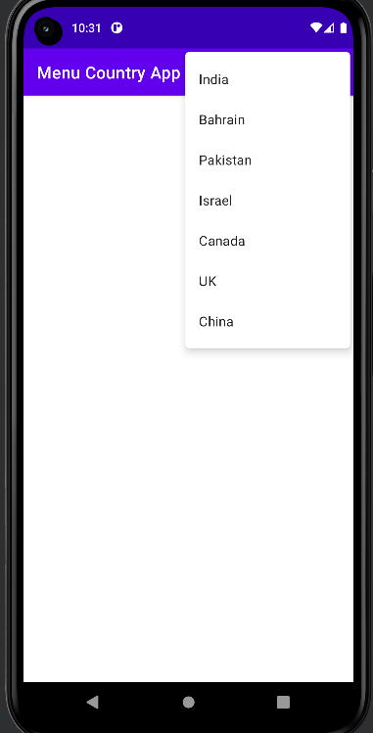 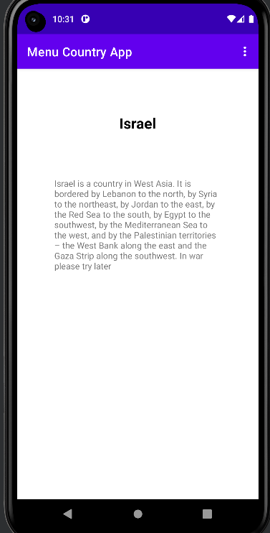

**Result:**

The mobile application was completed successfully

**Best Practices:**

1. Use meaningful variable and resource names for code readability.
2. Utilize string resources for text that may need to be translated or changed.
3. Implement a clean and organized layout using ConstraintLayout.

**Learning Outcomes:**

1. Understanding the implementation of menu-driven applications in Android.
2. Handling menu creation and item selection events in Android.
3. Utilizing XML resources for menu items and string values.
4. Designing responsive user interfaces using ConstraintLayout.